GET GOLFING OSHKOSH- Public Lessons
Corey Feller Golf Academy at Oshkosh Country Club invites ALL interested female golfers 18 years and older to learn how to play and enjoy the game of golf. Through a series of 5 - 1 hour group lessons for only $99 you will learn and experience all aspects of golf. If you are a new golfer or a golfer coming back to the game after a period of time off, this is your opportunity and I invite you to sign up today.

Dates of Instruction (Session 1- Saturdays@ 10:30am):
5/11: Introduction of Golf and Putting
5/18: Chipping & Pitching
5/25: Irons
6/1: Woods- Rules

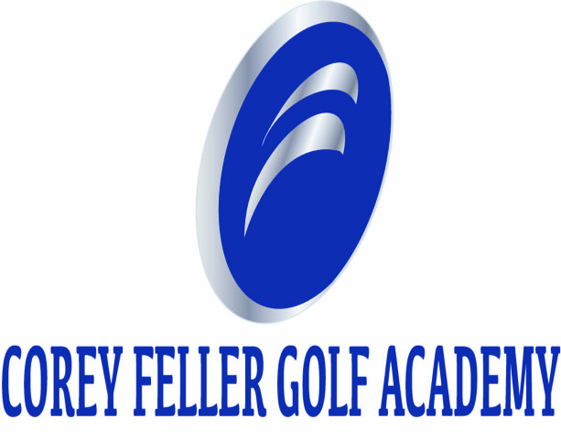
6/8: TPI and On Course Experience- (1.5 hours)

Dates of Instruction (Session 2- Saturdays@ 10:30am):
6/29: Introduction of Golf and Putting
7/20: Chipping & Pitching
7/27: Irons
8/3: Woods- Rules
8/24: TPI and On Course Experience (1.5 hours)

Please sign up with Corey Feller at OCC Pro Shop or call/text 920-858-7948
Classes are limited to the first 8 paid golfers

